Online movie ticket booking system srs

**Certificate**

I, , Enrolment number: , certify that the SDS Project Report entitled “Online movie ticket booking system” is done by me and it is an authentic work.

The matter embodied in this project work has not been submitted earlier for the award of any degree or diploma to the best of my knowledge and belief.

Certified that the Project Report entitled “Online movie ticket booking system” done by the above student is completed under my guidance.

Signature of the Guide

Date:

Name of the Guide:

Designation:

**FORMAT FOR TABLE OF CONTENTS**

**TABLE OF CONTENTS**

|  |  |  |
| --- | --- | --- |
| **S No** | **Topic** | **Page No** |
| 1 | Certificate | - |
| 2 | Acknowledgements | - |
| 3 | List of Tables/Figures/Symbols | - |
| 4 | Chapter 1: Problem Definition |  |
| 5 | Chapter 2: System Analysis And Design |  |
| 6 | Chapter 3: Summary and Future Scope |  |

**FORMAT FOR LIST OF TABLES/FIGURES/ SYMBOLS**

**LIST OF FIGURES**

|  |  |  |
| --- | --- | --- |
| **Figure No** | **Title** | **Page No** |
| 1 | Block Diagram |  |
| 2 | Use Case |  |
| 3 | E-R Diagram |  |
| 4 | Data Flow Diagram |  |
| 5 | Flow Chart |  |

**SOFTWARE REQUIREMENT SPECIFICATIONS**

**1.INTRODUCTION**

The "Online Movie Ticket Booking System" has been developed to override the

problems prevailing in the practicing manual system. This software is supported to

eliminate and in some cases reduce the hardships faced by this existing system.

Moreover this system is designed for the particular need of the company to carry out

operations in a smooth and effective manner.

Online movie ticket booking system is basically made for providing the customers an anytime and anywhere service for booking cinema tickets and providing information about the movies and their schedule online.

Admin can use Online Movie Ticket Booking System Project to insert and delete data such as movie description, movie schedule which will update the related webpage and will be accessible by the customers.

Online Movie Ticket Booking System provide another way for the customers to buy cinema ticket. This system reduces work load on customers, it is an automatic ticket booking system.

This system is basically aimed to provide complete information of the movie and schedule to the customer, according to which he can book the tickets.

* 1. **Problem with the current system**

a)Wastage of Time:

Today everybody has a busy life and standing in a long queue for a couple of tickets, is just not acceptable.

#### b)You can not choose your favourite seat:

When you book movie tickets online you get the privilege of choosing your favorite seat number. Whereas in offline bookings the seats are given by the authority and changing it is too inconvenient.

#### c)No Promotions and Discounts:

There is no Promotions and discounts available in offline movie ticket booking system.

#### d)Pay with cash only:

Facilities like pay by using debit or credit card, net banking etc are not available in booking a ticket offline.

#### e)Can not check the availability of tickets:

If you want to check the availability of tickets for a particular show so, for that you have to visit the cinema hall.

* 1. **About the proposed system**
     1. **Objective**

The main objective of our online ticket booking system project is to provide an alternate and convenient way for a customer to buy cinema tickets. It is an automatic system. After the data has been fed into the database, the staff does not need to do anything with the order once it is received through the system. In fact, there is similar system on the internet, but there is no refund method found in the existing system. The goals of our system are:

* To provide a anytime anyplace service for the customer.
* To minimize the number of staff at the ticket box.
* To promote the film on the internet.
* To increase the profit.
* To obtain statistic information from the booking record.
* To increase efficiency of managing the Movie, Tickets.

* + 1. **Purpose**

The purpose of the document is to collect and analyze all assorted ideas that have come up to define the system, its requirements with respect to consumers. Also, we shall predict and sort out how we hope this product will be used in order to gain a better understanding of the project, outline concepts that may be developed later, and document ideas that are being considered, but may be discarded as the product develops.

In short, the purpose of this SRS document is to provide a detailed overview of our software product, its parameters and goals. This document describes the project's target audience and its user interface, hardware and software requirements. It defines how our client, team and audience see the product and its functionality. Nonetheless, it helps any designer and developer to assist in software delivery lifecycle (SDLC) processes.

* + 1. **Scope**

It may help collecting perfect management in details. In a very short time, the collection will be obvious, simple and sensible. It will help a person to know the management of passed year perfectly and vividly. It also helps in current all works relative to Online Movie Ticket Booking System. It will be also reduced the cost of collecting the management & collection procedure will go on smoothly.

## **Software Model Used**

The **waterfall model** is a linear sequential (non-iterative) design approach for software development, in which progress flows in one direction downwards (like a waterfall) through the phases of conception, initiation, analysis, design, construction, testing, deployment and maintenance.  In "The Waterfall" approach, the whole process of software development is divided into separate phases. In this Waterfall model, typically, the outcome of one phase acts as the input for the next phase sequentially.

The following illustration is a representation of the different phases of the Waterfall Model.

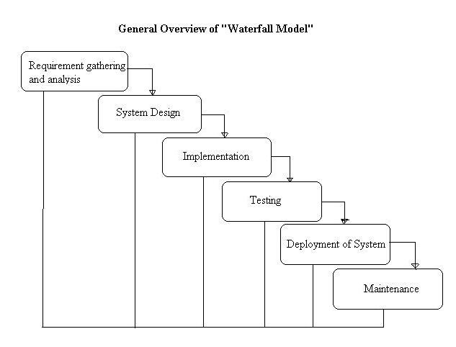

The sequential phases in Waterfall model are −

* **Requirement Gathering and analysis** − All possible requirements of the system to be developed are captured in this phase and documented in a requirement specification document.
* **System Design** − The requirement specifications from first phase are studied in this phase and the system design is prepared. This system design helps in specifying hardware and system requirements and helps in defining the overall system architecture.
* **Implementation** − With inputs from the system design, the system is first developed in small programs called units, which are integrated in the next phase. Each unit is developed and tested for its functionality, which is referred to as Unit Testing.
* **Integration and Testing** − All the units developed in the implementation phase are integrated into a system after testing of each unit. Post integration the entire system is tested for any faults and failures.
* **Deployment of system** − Once the functional and non-functional testing is done; the product is deployed in the customer environment or released into the market.
* **Maintenance** − There are some issues which come up in the client environment. To fix those issues, patches are released. Also to enhance the product some better versions are released. Maintenance is done to deliver these changes in the customer environment.

All these phases are cascaded to each other in which progress is seen as flowing steadily downwards (like a waterfall) through the phases. The next phase is started only after the defined set of goals are achieved for previous phase and it is signed off, so the name "Waterfall Model". In this model, phases do not overlap.

**Waterfall Model – Application**

Some situations where the use of Waterfall model is most appropriate are −

* Requirements are very well documented, clear and fixed.
* Product definition is stable.
* Technology is understood and is not dynamic.
* There are no ambiguous requirements.
* Ample resources with required expertise are available to support the product.
* The project is short.

**Waterfall Model – Advantages**

Some of the major advantages of the Waterfall Model are as follows −

* Simple and easy to understand and use
* Easy to manage due to the rigidity of the model. Each phase has specific deliverables and a review process.
* Phases are processed and completed one at a time.
* Works well for smaller projects where requirements are very well understood.
* Easy to arrange tasks.

**Waterfall Model – Disadvantages**

The major disadvantages of the Waterfall Model are as follows −

* Poor model for long and ongoing projects.
* Not suitable for the projects where requirements are at a moderate to high risk of changing. So, risk and uncertainty are high with this process model.
* It is difficult to measure progress within stages.
* Cannot accommodate changing requirements.
* Adjusting scope during the life cycle can end a project.

## **Methodology Used For Data Collection**

### **1.4.1 Primary Sources:**

A primary data source is an original data source, that is, one in which the data are collected firsthand by the researcher for a specific research purpose or project. Primary data can be collected in a number of ways. However, the most common techniques are self-administered surveys, interviews, field observation, and experiments. Primary data collection is quite expensive and time consuming compared to secondary data collection. Notwithstanding, primary data collection may be the only suitable method for some types of research.

Some examples of primary sources are:

* raw data.
* original research (journal articles, books).
* diary entries, letters and other correspondence.
* eyewitness accounts or interviews.
* legal documents, government documents, public records (e.g. birth certificates).
* records or other documents created by organizations.

### **1.4.2 Secondary Sources:**

## Secondary data is usually defined in opposition to primary data. The latter is directly obtained from first-hand sources by means of questionnaire, observation, focus group, or in-depth interviews, whereas the former refers to data collected by someone other than the user. In other words, secondary data refers to data that have already been collected for some other purpose. Yet, such data may be very useful for one’s research.

Some examples of secondary sources are:

* journal articles that comment on or analyse research.
* textbooks.
* dictionaries and encyclopaedias.
* books that interpret, analyse.
* biographies.

We have used secondary sources in this project.

## 1.5 System Requirement Tools

1. SQLite

SQLite is an in-process library that implements a self-contained, zero configuration, transactional SQL database engine. The code for SQLite is in the public domain and is thus free for use for any purpose, commercial or private. SQLite is the most widely deployed database in the world with more applications than we can count, including several high-profile projects.

### 

### 1.5.2 Hardware Requirements

1. 4GB RAM  
2. GPRS or Location Tracker

Chapter 2

System Analysis and Design

# 2.1 Physical Design

## 2.1.1 Block Diagram

TICKET NO.

ONLINE MOVIE TICKET

BOOKING

MOVIE NAME

MOVIE TIME

TICKET PRICE

SEAT NO.

HALL NO.

## 2.1.2 Use Case

ONLINE MOVIE TICKET BOOKING

ADMIN

USER

## 2.1.3 E-R Diagram

In **ER** modeling, the structure for a **database** is portrayed as a **diagram**, called an **entity-relationship diagram** (or **ER diagram**), that resembles the graphical breakdown of a sentence into its grammatical parts. Entities are rendered as points, polygons, circles, or ovals.

The Entity Relationship data model is based on a perception of a real world that consist of a collection of basic objects, called Entities, and Relationships among these objects.

Entity relationship diagrams are abstractions of the real world which simplify the problem to be solved while retaining its essential features.

**Entity relationship diagrams are used to**:

Identify the data that must be captured, stored and retrieved in order to support the business activities performed by an organization and identify the data required to derive and report on the performance measures that an organization should be monitoring.

* Entity relationship diagrams have three different components:
  + **ENTITIES**
  + **ATTRIBUTES**
  + **RELATIONSHIPS**
* **Entity: -** An entity may be defined as a thing which is recognized as being capable of an independent existence and which can be uniquely identified. An entity is an abstraction from the complexities of some domain.
* **Relationship: -** A relationship captures how two or more entities are related to one another. Relationships can be thought of as verbs, linking two or more nouns.

There are potentially three types of relationship which can exist between two different entities:

* One-to-One Relationships
* One-to-Many Relationships
* Many-to-Many Relationships
* **Attributes: -** Entities are further described by their attributes (sometimes called data elements). These are the smallest units of data that can be described in a meaningful manner.
* An attribute is some quality about the entities that we are interested in and want to hold on the database

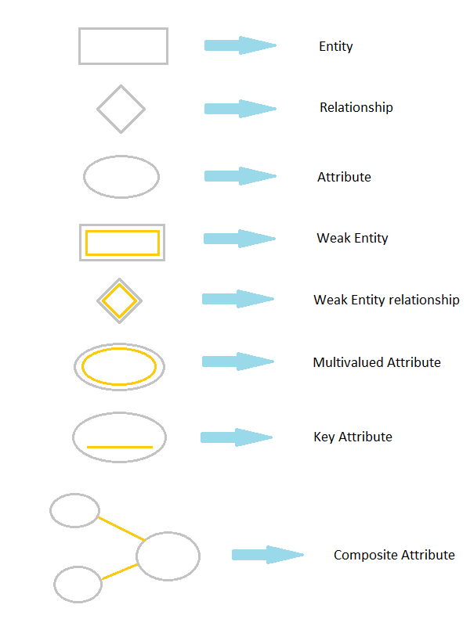

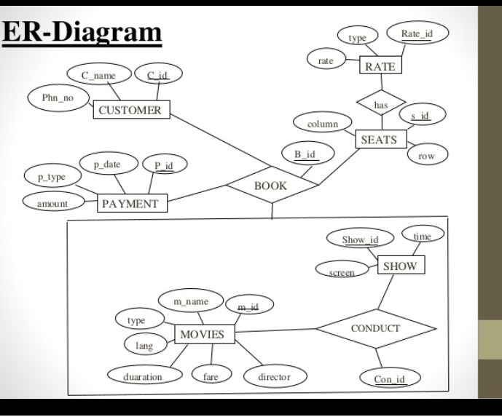

## 2.1.4 DFD

* A data flow diagram is a graphical technique that depicts information flow and the transforms that are applied as data move from input to output.
* The data flow may be partitioned into a level that represents software at any level of abstraction.
* In fact, DFD may be partitioned into levels that represent increasing information flow and functional detail.
* A level zero DFD called a context model, represent the entire software element as a single bubble with input and output data indicated by incoming and outgoing arrows respectively.
* Each process represented at level is sub functions of the overall system depicted in the context model.
* The data flow diagram is a graphical tool that can be very valuable during the software requirement analysis.
* However the diagram can cause confusion if its function is confused with the flow chart.
* A DFD depicts information flow without explicit representation of processed logic.
* A few simple guidelines can aide immensely during deviation of a data flow diagram:
  + The level zero DFD should depict the software as a single bubble.
  + Primary input and output should be carefully noted.
  + Refinement should begin isolating processes, data items stores to be represented the next level.
  + An arrow and bubble should be labeled with meaningful names.
  + One bubble at a time should be refined.
* There is a natural tendency to over complicate the DFD.
* This occurs because the analyst attempts to show too much detail too early or represents procedural aspects of the software in the information flow.
* The refinement of DFD continues until each bubble performs a simple function that is until the processes represented by the bubbles perform a function that would be easily implemented as a program component.

**Notations used in DFD**

Symbols Meanings

It represents a data-item or collection of data-item. The arrow indicates direction of Data-flow.

It represents data storage.

It represents a process that transforms incoming data to outgoing data.

It represents data storage.

It represents data storage.

2.1.4.1

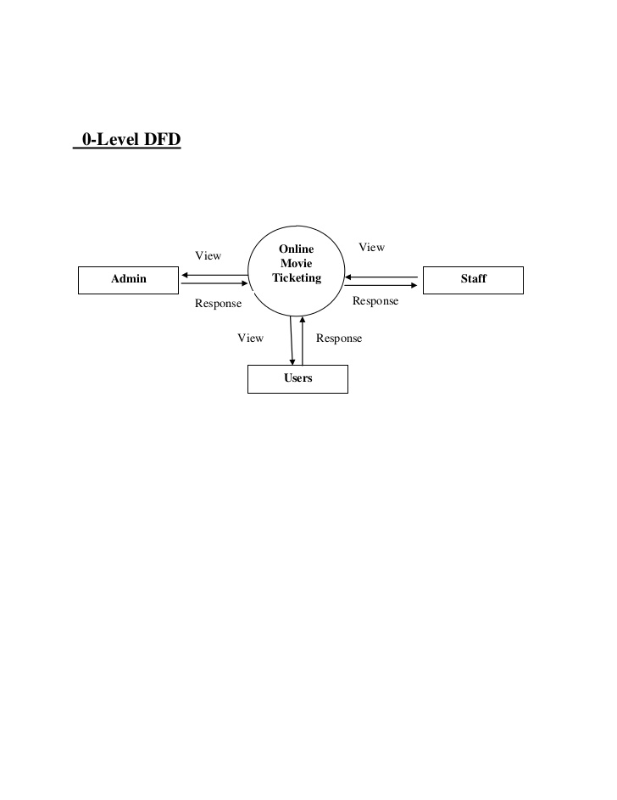

2.1.5 Flowchart

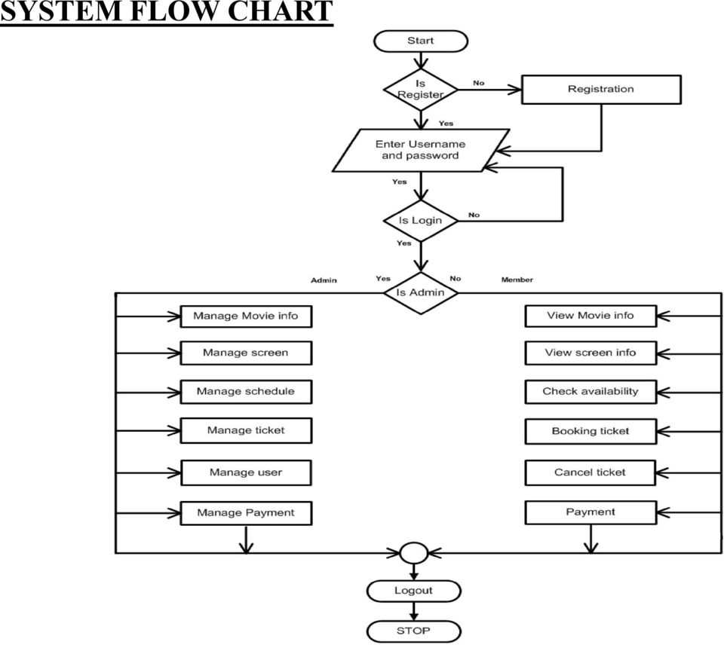

CHAPTER-3

Summary & Future Scope

3.1 Summary

The "Online Movie Ticket Booking System" has been developed to override the problems prevailing in the practicing manual system. This software is supported to eliminate and in some cases reduce the hardships faced by this existing system. Moreover this system is designed for the particular need of the company to carry out operations in a smooth and effective manner.

The application is reduced as much as possible to avoid errors while entering the data. It also provides error message while entering invalid data. No formal knowledge is needed for the user to use this system. Thus, by this all it proves it is user-friendly. Online Movie Ticket Booking System , as described above, can lead to error free, secure, reliable and fast management system. It can assist the user to concentrate on their other activities rather to concentrate on the record keeping. Thus, it will help organization in better utilization of resources.

The main objective of the Project on Online Movie Ticket Booking System is to manage the details of Movie, Tickets, Booking, Show Timing, Customer. It manages all the information about Movie, Audi, Customer, Movie. The project is totally built at administrative end and thus only the administrator is guaranteed the access. The purpose of the project is to build an application program to reduce the manual work for managing the Movie, Tickets, Audi, Booking. It tracks all the details about the Booking, Show Timing, Customer.

Every organization, whether big or small, has challenges to overcome and managing the information of Tickets, Movie, Show Timing, Audi, Customer. Every Online Movie Ticket Booking System has different Movie needs; therefore, we design exclusive employee management systems that are adapted to your managerial requirements. This is designed to assist in strategic planning, and will help you ensure that your organization is equipped with the right level of information and details for your future goals. Also, for those busy executives who are always on the go, our systems come with remote access features, which will allow you to manage your workforce anytime, at all times. These systems will ultimately allow you to better manage resources.

3.2 Future Scope

It may help collecting perfect management in details. In a very short time, the collection will be obvious, simple and sensible. It will help a person to know the management of passed year perfectly and vividly. It also helps in current all works relative to Online Movie Ticket Booking System. It will be also reduced the cost of collecting the management & collection procedure will go on smoothly.